Docker Basics Assignment -1

* Verify the installation by running a test container.

* Write a Dockerfile to containerize the application.

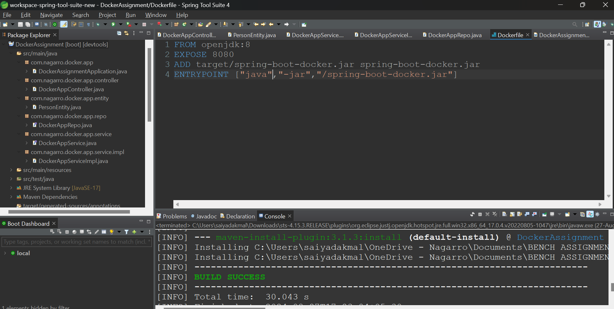



* Build the Docker image and run a container from it.

* Use Docker commands to list, start, stop, and remove containers.

* Inspect running containers and view logs.

* Write a docker-compose.yml file to define a multi-container application.

* Use Docker Compose to bring up the application and ensure all services are running correctly.

* Create a private Docker registry or use Docker Hub.
* Push your Docker images to the registry.

Pull the images from the registry and run them locally.

